## **Size：W0.90m*H1.2m**

## **Single-shot 8-frame Direct Imaging with an Effective Frame Rate up to 40 Tfps and a two-dimensional Space-bandwidth-product beyond 65,500**

## Congying Wang, Rui Zhang, Xuanke Zeng,* Yi Cai, Xiaowei Lu, Shixiang Xu, Jingzhen Li, and Dianyuan Fan

College of Physics and Optoelectronic Engineering, Shenzhen University, Shenzhen 518060, China

*Corresponding Author

## **Abstract** Compared with computational imaging, direct imaging is still a concern since it provides more intuitive and reliable spatiotemporal information of the target. The paper presents a single-shot ultrafast framing direct imaging based on polarization-spatial-encoding via. non-collinear optical parametric amplification (OPA) with remarkable imaging seed and spatiotemporal resolutions. Targeted with laser-induced air plasma, our experiments verify the single-shot imaging system has carried out 8-frame direct imaging by 25 fs temporal resolution, 40 trillion frames per second (Tfps) effective frame rate, and beyond 25.6 lp/mm spatial resolution over a 10×10 mm2 field-of-view. The experimental results also show the capture of richer spatiotemporal details of air plasma in the early stage (0~3.6 ps) after excitation. The temporal window can be flexibly expanded by changing the frame interval.This work provides a powerful tool for accurately understanding dynamic processes on the femtosecond to picosecond scale for non-repeatable or random dynamic scenarios.

**Introduction** Ultrafast optical imaging captures spatiotemporal information of dynamic scenes on time scales ranging from nanoseconds to femtoseconds, making it a focal point of recent research. As a powerful tool, it has been successfully applied in various fields, including physics [1-4], chemistry [5], and biology [6]. As is known, it can be realized by pump-probe, which is qualified to reveal diverse macroscopic and microscopic ultrafast dynamic processes [7], where the target dynamic scenes are repeatable with high stability. For non-repeatable or random dynamic scenarios, such as shockwave propagation and laser-matter interactions [8], the single-shot mode is required for ultrafast optical imaging.

**Principle and Experimental Setup** The idea of the framing imaging system is based on polarization-spatial encoding. First, polarizing optical devices split the probe signal carrying ultrafast target events into two parallel branches with horizontal and vertical polarization, respectively. Each branch then uses cascaded OPAs to extract multiple temporal sequence images from spatially separated idlers.

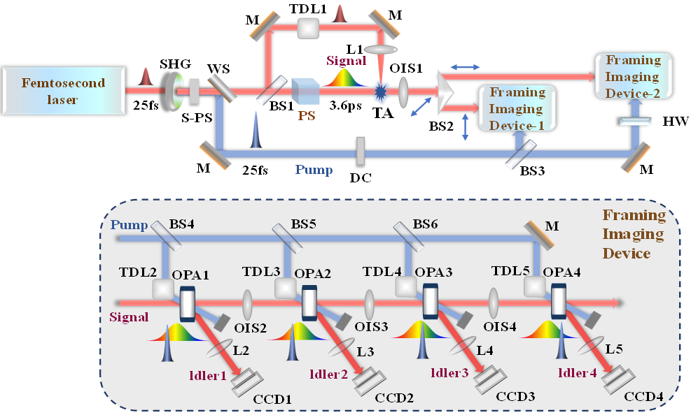

**Fig. 1.** Experimental setup for the single-shot framing imaging technology with an effective frame rate of 40 Tfps using polarization-spatial encoding.

**Results and Discussion** Changes in transmittance reflect the modulation of the probe signal pulse by the air plasma, further revealing the evolution of the plasma's electron density. We plotted the transmittance of the plasma along the *z*-axis propagation direction and used the above method to calculate the electron density distribution along the *z*-axis, as shown in Figure 2(a). per unit volume generate stronger electric fields, leading to higher oscillation frequencies. To validate the system's capability to record non-uniform transient events, we used varying frame intervals, setting the relative delays of the eight pump beams to 0, 0.025, 0.125, 0.225, 0.5, 1.25, 2.05, and 3.05 ps. The framing images of the plasma's evolution are shown in Figure 6(b). From 0 fs to 3.05 ps, the plasma propagated from right to left, and during the early stages (0-0.5 ps), the modulation of the probe signal increased rapidly, causing the transmittance to drop sharply. At 0.5 ps, the transmittance reached its minimum, indicating the peak electron density. Then, the plasma density remained high but gradually declined from 0.5 ps to 3.05 ps. Since the duration of plasma generation, relaxation, and dissipation exceeded the probe light's pulse width, only part of the evolution process was captured. To observe the entire process, the probe signal pulse width could be further extended.

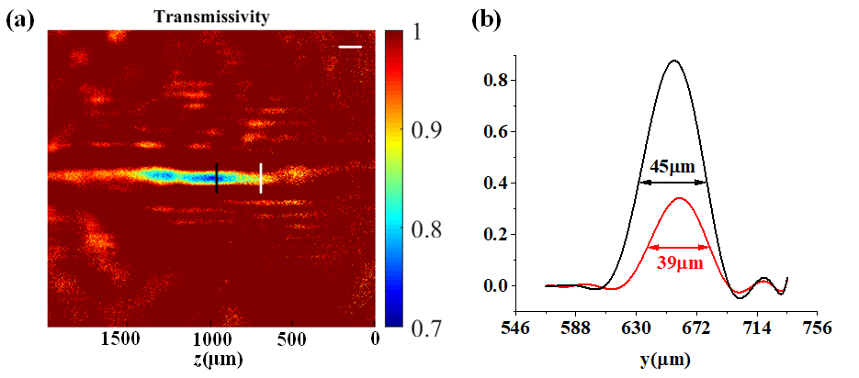

**Fig. 2. (a)** Transmittance image of femtosecond laser-induced air plasma recorded by idler, and **(b)** the normalized modulation intensity (MI) profiles vertical to *z*-direction along the black and white lines marked in Figure 4(a). Scale bar: 100 μm.

**Conclusion** To accurately, intuitively, and reliably observe ultrafast target events with abundant spatiotemporal details, this paper proposes a single-shot ultrafast framing direct imaging based on polarization-spatial-encoding through multiple non-collinear OPA with remarkable imaging seed and spatiotemporal resolutions. In order to address the technological and engineering challenges faced by FINCOPA in increasing the frame number, a dual-branch parallel architecture has been designed to realize 8-frame single-shot ultrafast imaging.

**Funding.** National Natural Science Foundation of China (XXXX).

**Disclosures.** The authors declare no conflicts of interest.

**References**

1. A. B. Zylstra, O. A. Hurricane, D. A. Callahan, *et al.*, “Burning plasma achieved in inertial fusion,” Nature **601**(7894), 542-548 (2022).

2. Y. Fuentes-Edfuf, M. Garcia-Lechuga, J. Solis, *et al*., “Ultrafast Electron Dynamics and Optical Interference Tomography of Laser Excited Steel,” Laser Photon. Rev. 16(12), 2200511(2022).